
Banbury Star Cyclists’ Club Open 23 Mile “HARDRIDERS” Time Trial

Promoted for and on behalf of Cycling Time Trials under their Rules and Regulations

And kindly sponsored by the wonderful Hook Norton Brewery



To be held on the K4/23 Course on Sunday 1st of March 2020.
First Rider off at 1010hrs.

Welcome to this challenging early-season event. Please take care on Sunrising Hill, which is known to be steep and slippery with a tight left hand bend on the way down.

(1) Event Organiser

Oliver Wright Dove Cottage
TT Secretary, BSCC Main Street
07767 645281 Long Compton
TTSecretary@banburystar.co.uk WARKS, CV36 5JS
With thanks to the committee and members of BSCC and elsewhere for promoting and making the event happen. With special thanks to our lead timekeeper, marshals and kitchen staff.

Please, enjoy the event!

(2) Timekeepers

Oliver Wright, Banbury Star CC (Assistant, Start)
Howard Waller, Python RT (Lead, Finish)

(3) Awards

I thought we’d try something different with prizes this time around, as it is often only the winners who walk away with an award at the end of the day despite the fact that everyone puts in their maximum effort. Therefore, awards and gifts will be given on the following basis:

Senior/Vet male and female winners will receive their entry fee back, as will the winning male and female Espoirs and Juniors.

The overall fastest team of three will also receive £10 each.

Other gifts will then be awarded on a pre-determined basis to those riders finishing on a ten, even if they didn’t start on one! So, if you are lucky enough to finish 10th, 20th, 30th, 40th, 50th, 60th or 70th then you are in, well, luck. As we have 71 riders, the fight to not be 71st will be tight!

All prizes will be awarded straight after the event.

(4) Event HQ

Wroxton Village Hall
Stratford Road
Wroxton
OX15 6PZ

There is some parking at the Village Hall but there will likely be options elsewhere if space is at a premium.

Race HQ will be open from 0845hrs for signing on and will close shortly after the presentations, no later than 1300hrs.

(5) The Course – K4/23

https://connect.garmin.com/modern/course/12799050

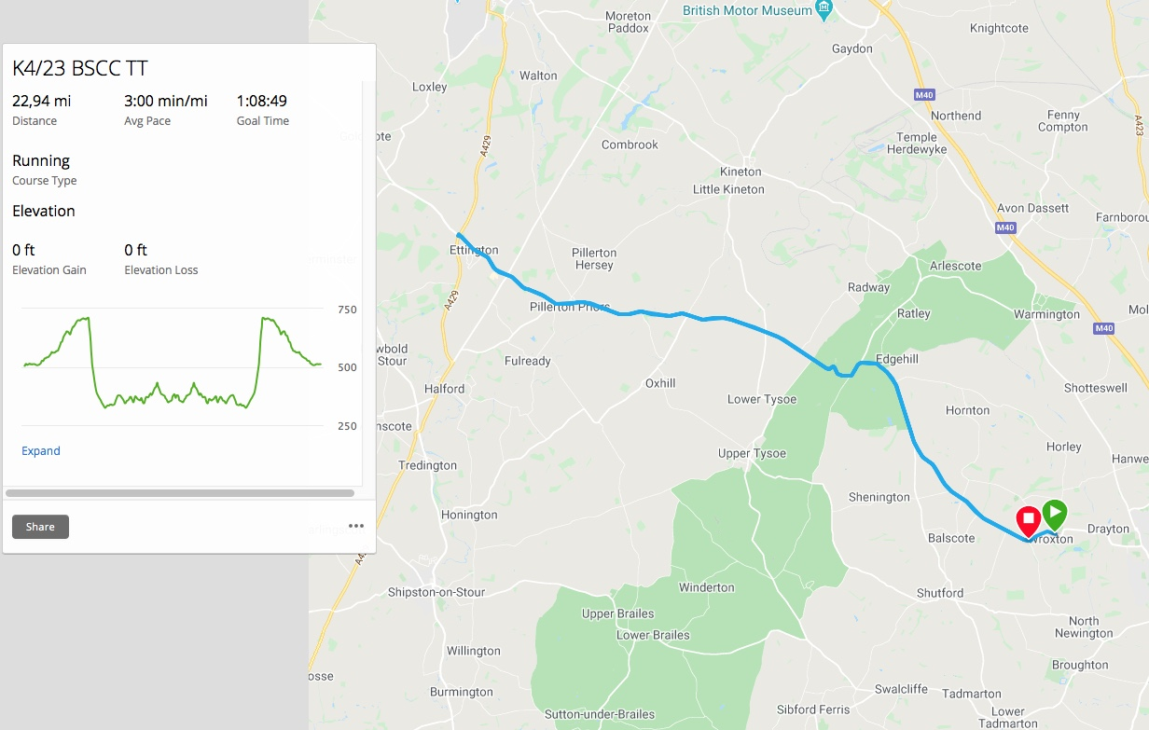

From the HQ, turn left to the disused pub a hundred or so metres away. Proceed WNW to Ettington roundabout and return to the edge of Wroxton Village.

Marshals will be on course to provide visibility, but do TAKE CARE.

(6) NOTES & CAUTIONS

REMEMBER to sign out after the event and return your number.

DO NOT use turbo trainers in the vicinity of residential properties please. We don’t like complaints from the public.

WORKING REAR LIGHTS ARE NOW MANDATORY AT THE START LINE. Please see the CTT Guidance Note in case you are not familiar with the rule. I will not permit you to start unless you have a working rear light at that moment.

No vehicles other than those of the timekeeper and marshals may park in the vicinity of the finish. DO NOT pass the start after the event has started.

DO NOT stop at the finish. Please carry on to the HQ where your result will be posted reasonably promptly.

In the interests of safety, CTT and the promoters strongly advise the use of a hard shell helmet that meets the necessary standards. All juniors must wear an approved hard shell helmet.

number | start_time | firstname | lastname | club | gender | category
10 | 1010 | Martin | Kelly | Banbury Star Cyclists' Club | Male | Veteran
11 | 1011 | Darren | Alexander | Team Cherwell | Male | Veteran
12 | 1012 | Daniel | Nash | Oxford University CC | Male | Senior
13 | 1013 | David | Nath | VØST RT | Male | Senior
14 | 1014 | Helen | French | Banbury Star Cyclists' Club | Female | Veteran
15 | 1015 | Mark | Wise | Team Jewson - MI Racing ~Poly Pipe~McCann | Male | Veteran
16 | 1016 | Stuart | Quick | Banbury Star Cyclists' Club | Male | Veteran
17 | 1017 | Naomi | De Pennington | Banbury Star Cyclists' Club | Female | Veteran
18 | 1018 | Jill | Mckinnon | Kenilworth Wheelers | Female | Veteran
19 | 1019 | Katie | Pamphlett | Banbury Star Cyclists' Club | Female | Junior
20 | 1020 | James | Garrett | Rugby Velo | Male | Senior
21 | 1021 | James | Lloyd | JRC Shutt Ridley RT | Male | Junior
22 | 1022 | Michael | Warner | Stratford Cycling Club | Male | Veteran
23 | 1023 | Emma | Tod | Newcomers Cycling Club | Female | C5
24 | 1024 | William | Morgan | Banbury Star Cyclists' Club | Male | Veteran
25 | 1025 | Harry | Kirby | Vision Innovative Leisure Racing Team | Male | Junior
26 | 1026 | Neil | White | Ambion Racing Team | Male | Veteran
27 | 1027 | Karl | Moseley | Fishface Cycles RT | Male | Veteran
28 | 1028 | Annie | Heaney | Team Cherwell | Female | Senior
29 | 1029 | Katherine | Daniels | Shutt Velo Test Team | Female | Senior
30 | 1030 | James | Middleton | MediaVelo | Male | Senior
31 | 1031 | Tobias | Wiesand | Banbury Star Cyclists' Club | Male | Senior
32 | 1032 | Lydia | Watts | Liv AWOL | Female | Espoir
33 | 1033 | Mike | Lloyd | Oxonian CC | Male | Veteran
34 | 1034 | Denise | Shepherd | Banbury Star Cyclists' Club | Female | Veteran
35 | 1035 | Angus | Fisk | Oxford University CC | Male | Senior
36 | 1036 | Nick | Giles | Poco Loco Cycling R.T. | Male | Veteran
37 | 1037 | George | Thorne | Beacon Roads CC | Male | Senior
38 | 1038 | Kimberley | Pickett | Bicester Millennium CC | Female | Senior
39 | 1039 | Stephen | Goddard | 1485 Tri Club | Male | Veteran
40 | 1040 | James | Richardson | North Bucks RC | Male | Senior
41 | 1041 | Blaine | Carpenter | JRC Shutt Ridley RT | Male | Espoir
42 | 1042 | Benedict | Heaney | Team Cherwell | Male | Senior
43 | 1043 | Matt | Norris | Banbury Star Cyclists' Club | Male | Veteran
44 | 1044 | Mark | Davis | Banbury Star Cyclists' Club | Male | Veteran
45 | 1045 | Simon | Smith | JRC Shutt Ridley RT | Male | Veteran
46 | 1046 | Lee | Heron | Banbury Star Cyclists' Club | Male | Veteran
47 | 1047 | Reed | Partridge | Ambion Racing Team | Male | Veteran
48 | 1048 | Mark | Mallalue | Bicester Millennium CC | Male | Veteran
49 | 1049 | Daniel | Fleming | Kenilworth Wheelers | Male | Senior
50 | 1050 | Paul | Atkins | Kenilworth Wheelers | Male | Veteran
51 | 1051 | Luke | Souter | JRC Shutt Ridley RT | Male | Veteran
52 | 1052 | Mike | Kirby | Banbury Star Cyclists' Club | Male | Veteran
53 | 1053 | Michal | Wisowski | Banbury Star Cyclists' Club | Male | Senior
54 | 1054 | Luke | Norris | Banbury Star Cyclists' Club | Male | Senior
55 | 1055 | Peter | Oliver | ZeroBC Race Team | Male | Veteran
56 | 1056 | Anthony | Harriss | Mercedes AMG Petronas CC | Male | Veteran
57 | 1057 | Jacob | Bacon | North Cotswold CC | Male | Senior
58 | 1058 | Andrew | Harbourne | Cowley Road Condors CC | Male | Senior
59 | 1059 | Robert | Paul | Banbury Star Cyclists' Club | Male | Veteran
60 | 1100 | David | Mead | Race Rapid | Male | Veteran
61 | 1101 | Roger | Foster | Banbury Star Cyclists' Club | Male | Veteran
62 | 1112 | Roger | Cutler | Beacon Roads CC | Male | Senior
63 | 1103 | James | Bryant | Kenilworth Wheelers | Male | Veteran
64 | 1104 | Ian | Maconnachie | Banbury Star Cyclists' Club | Male | Senior
65 | 1105 | David | Fellows | Solihull CC | Male | Senior
66 | 1106 | Simon | Bull | Banbury Star Cyclists' Club | Male | Veteran
67 | 1107 | Nick | Gardener | VØST RT | Male | Senior
68 | 1108 | Paul | Ilott | Cowley Road Condors CC | Male | Veteran
69 | 1109 | Pete | Belsey | Banbury Star Cyclists' Club | Male | Senior
70 | 1110 | Jack | O'neill | Team Jewson - MI Racing ~Poly Pipe~McCann | Male | Senior
71 | 1111 | Graham | Martin | Banbury Star Cyclists' Club | Male | Veteran
72 | 1102 | Mark | Boyles | Banbury Star Cyclists' Club | Male | Veteran
73 | 1113 | Dan | Smith | Stratford Cycling Club | Male | Senior
74 | 1114 | Jonny | Smith | Bicester Millennium CC | Male | Senior
75 | 1115 | Dave | Johnson | VC 10 | Male | Veteran
76 | 1116 | Justin | Belcher | JRC Shutt Ridley RT | Male | Veteran
77 | 1117 | Phil | Brush | Winchcombe Cycling Club | Male | Senior
78 | 1118 | Malcolm | Moore | Team Jewson - MI Racing ~Poly Pipe~McCann | Male | Veteran
79 | 1119 | Rich | Collier | Banbury Star Cyclists' Club | Male | Veteran
80 | 1120 | Jacob | Tipper | Ribble Weldtite Pro Cycling | Male | Senior

